Let’s Keep Talking
Phase 6 communications toolkit
September/October 2021 – version 1

Contents

LTK Phase 6 1
Press release 1
Newsletter copy (internal and wider stakeholders) 2
Web copy 3
Posters 3
Videos 4
Digital screen images 4
Social media schedule 5
World Suicide Prevention Day 12

LTK Phase 6

Press release

**Embargoed until 00.01 Friday 10 September 2021**

Ex-Premier League footballer urges people to ‘keep talking’ to reduce suicide

Former Premier League footballer Clarke Carlisle is making an emotional appeal for people to ‘keep talking’ in a bid to stop men from taking their own lives.

The 41-year-old is supporting the latest phase of Lancashire and South Cumbria Health and Care Partnership’s Let’s Keep Talking campaign which is being launched today – World Suicide Prevention Day (10 September 2021).

Suicide rates across the region are the third highest in England and men are three times more likely to take their life by suicide than women.

The former Blackpool, Burnley and Preston North End defender has spoken openly about his own battle with depression and previous suicide attempts.

“It’s no secret that I’ve struggled with my mental health for many years, so much so there have been times when I have been intent on taking my own life.

“Too many people still don’t understand depression is an illness and people can’t just ‘pull themselves together’. We need to end the stigma, we need people, especially young men, to open up about their mental health and talk about feelings of suicide.

“I feel blessed that I’m in a much better place now and I want people who are facing similar struggles to what I’ve experienced to know that there is a light at the end of the tunnel.”

Sixty-seven per cent of people who die by suicide are not known to mental health services – and it is the biggest killer of men under 49.

The past 18 months has been a very difficult time for a lot of people. It is more important than ever for people to reach out if they are struggling with their mental health.

Neil Smith, the Mental Health Multi-Agency Strategic Lead for the Lancashire and South Cumbria Health and Care Partnership, said: “We’re extremely grateful to Clarke for getting behind our campaign. We know his personal experiences will resonate with so many other people – particularly young men.

“We know suicide isn’t the easiest subject to talk about, but if you’re worried about someone it’s OK to ask, ‘are you thinking about suicide?’ Listening is more powerful than people think and having these conversations could save a life.”

For more information and help and support visit Healthier Lancs and South Cumbria :: Male suicide (healthierlsc.co.uk)

Newsletter copy (internal and wider stakeholders)

Former Premier League footballer Clarke Carlisle is the new face of Lancashire and South Cumbria Health and Care Partnership’s Let’s Keep Talking suicide prevention campaign.

The 41-year-old is supporting the latest phase of the campaign which is being/was launched on World Suicide Prevention Day (10 September 2021).

The campaign urges people to ‘keep talking’ in a bid to stop men from taking their own lives.

Suicide rates across the region are the third highest in England and men are three times more likely to take their life by suicide than women.

Sixty-seven per cent of people who die by suicide are not known to mental health services – and it is the biggest killer of men under 49.

A suite of new materials, which includes posters, videos, social media messages and radio adverts, has been developed which you will hopefully see and hear over the next few weeks.

For more information and to download a copy of the toolkit please visit Healthier Lancs and South Cumbria :: Male suicide (healthierlsc.co.uk)

If you would like more information please contact lyndsey.shorrock@nhs.net.

Please can we also ask you to personally support this campaign by sharing any relevant social media posts, as well as encouraging the conversation about suicide and suicide awareness with friends, family, and colleagues.

If you are struggling yourself or you are concerned for somebody else, please visit the Lancashire and South Cumbria Health and Care Partnership website which contains resources, information, support organisations and other websites to help support your mental health. Visit Healthier Lancs and South Cumbria :: Mental Health support resources (healthierlsc.co.uk)

Web copy

Former Premier League footballer Clarke Carlisle is the new face of Lancashire and South Cumbria Health and Care Partnership’s Let’s Keep Talking suicide prevention campaign.

The 41-year-old is supporting the latest phase of the campaign which is being/was launched on World Suicide Prevention Day (10 September 2021).

The campaign urges people to ‘keep talking’ in a bid to stop men from taking their own lives.

Suicide rates across the region are the third highest in England and men are three times more likely to take their life by suicide than women.

Sixty-seven per cent of people who die by suicide are not known to mental health services – and it is the biggest killer of men under 49.

For more information please visit Healthier Lancs and South Cumbria :: Male suicide (healthierlsc.co.uk)

Posters

The images below are for illustrative purposes only. Please use the links below the images to download the high-resolution files.

Clarke Carlisle posters

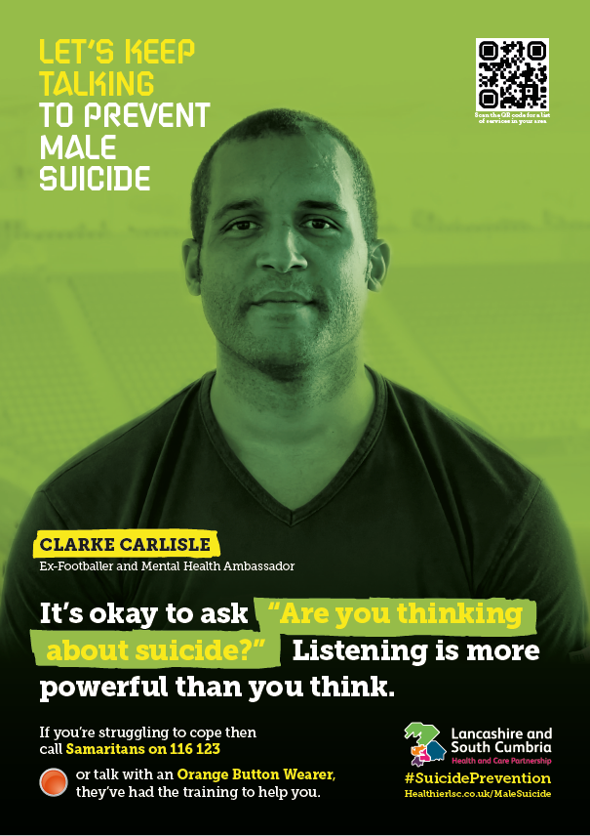  DBO564_LSCHP_Phase_6_Suicide_Stigma_Posters_A4_FINAL_Clarke.pdf (healthierlsc.co.uk) | 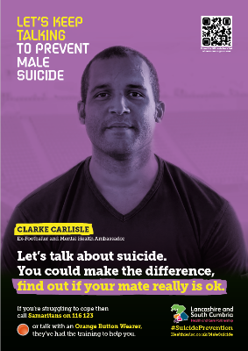  DBO564_LSCHP_Phase_6_Suicide_Stigma_Posters_A4_FINAL_Clarke_2.pdf (healthierlsc.co.uk)
Alternative posters

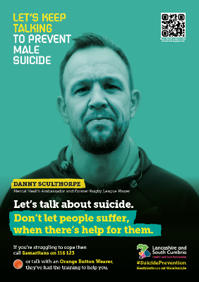  DBO564_LSCHP_Phase_6_Suicide_Stigma_Posters_A4_FINAL_Danny.pdf (healthierlsc.co.uk) | 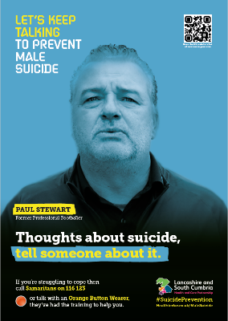  DBO564_LSCHP_Phase_6_Suicide_Stigma_Posters_A4_FINAL_Paul.pdf (healthierlsc.co.uk)

Videos

Please find a link below to a video featuring Clarke Carlisle speaking with his brother about his own personal mental health struggles and encouraging people to get help. This is a hugely powerful video which we would appreciate you sharing far and wide.

https://youtu.be/-uDAuaX3jso

Please find links to two of our previous videos below featuring former rugby player Danny Sculthorpe and former footballer Paul Stewart.

https://youtu.be/XKwcFuIYACg

https://youtu.be/MiD8zh9ne9E

Digital screen images

The images below are for illustrative purposes only. Please use the links below the images to download the high-resolution files. Please display these in places such as public waiting areas.

Clarke Carlisle images

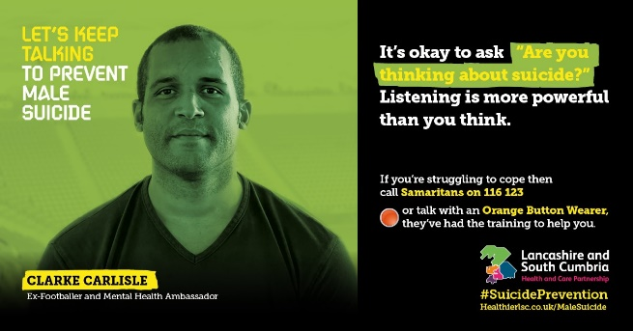  CC_digital_1.jpg (1200×628) (healthierlsc.co.uk) | 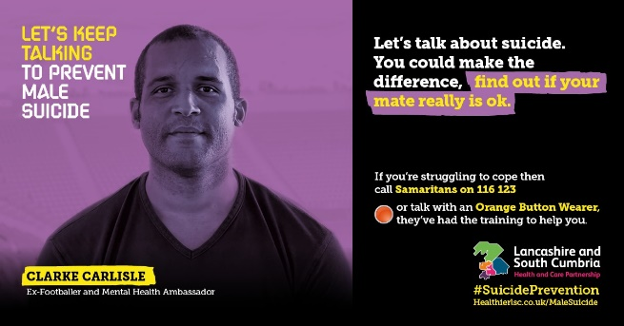  CC_digital_2.jpg (1200×628) (healthierlsc.co.uk)
Alternative images

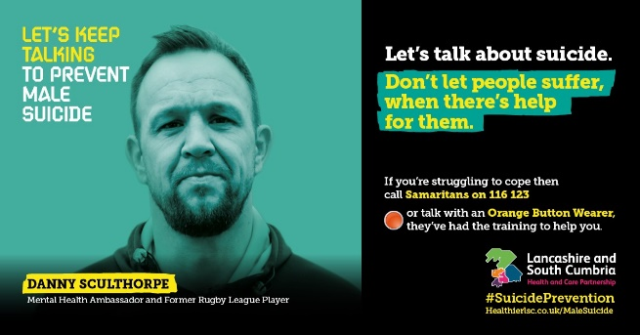  Danny_digital.jpg (1200×628) (healthierlsc.co.uk) | 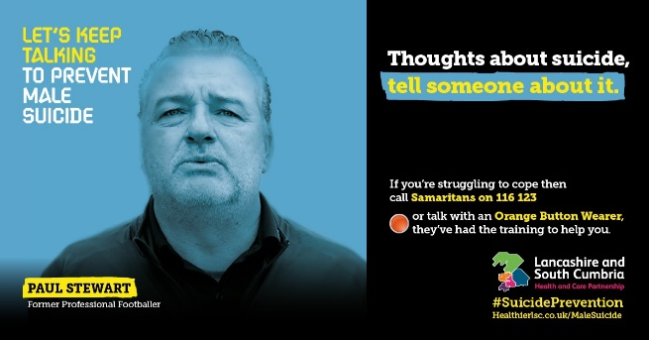  Paul_digital.jpg (1200×628) (healthierlsc.co.uk)

Social media schedule

Below are some suggested social media posts to use or adapt for your channels.

Depending on the social media management systems you use, if you have the ability, please create an ‘LKT phase 6’ campaign for evaluation purposes.

The hashtag for the campaign is: #StartTheConversation, other relevant hashtags include: #SuicidePrevention #MentalHealth #AntiStigma

The thumbnails below are for illustrative purposes only. Please download the high-resolution image by clicking on the link below the image.

Launch day posts – World Suicide Prevention Day 10/9/21

Please use the posts below across all your channels on Friday 10 September to launch the latest phase of this campaign to coincide with World Suicide Prevention Day (WSPD).

Please see the end of the toolkit for more WSPD resources.

Copy | Image thumbnail/asset
Launch Day posts (WSPD 10/9/21)
Facebook, Insta and Twitter  Suicide is the biggest killer of men under 49… we can change that.  On World Suicide Prevention Day, we’ve teamed up with ex-footballer Clarke Carlisle to encourage people to reach out if they’re struggling 💙  #StartTheConversation ➡️ https://www.healthierlsc.co.uk/MaleSuicide #WSPD2021 | 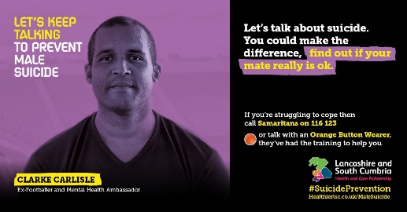  CC_digital_2.jpg (1200×628) (healthierlsc.co.uk)
Facebook, Insta and Twitter  🗣️ It’s World Suicide Prevention Day and ex-Premier League footballer Clarke Carlisle is working with us to encourage more people to talk about suicide.  Find out more ➡️ https://www.healthierlsc.co.uk/MaleSuicide  #WSPD2021 https://youtu.be/-uDAuaX3jso | When copying and pasting please ensure it is the YouTube video which displays in the post.
Facebook, Insta and Twitter  It’s World Suicide Prevention Day and ex-footballer Clarke Carlisle is encouraging men to open up about their mental health and talk about feelings of suicide 💙  Find out more ➡️ https://www.healthierlsc.co.uk/MaleSuicide  #WSPD2021 https://youtu.be/-uDAuaX3jso | When copying and pasting please ensure it is the YouTube video which displays in the post.
Facebook and Insta  It’s World Suicide Prevention Day and we’ve teamed up with ex-footballer Clarke Carlisle to talk about suicide and men’s mental health 👨🏾  Suicide is the biggest killer of men under 49 and we want to change this.  We want to get men talking! 🗣️ Find out more ➡️ https://www.healthierlsc.co.uk/MaleSuicide #WSPD2021  Twitter  It’s World Suicide Prevention Day and we’ve teamed up with ex-footballer Clarke Carlisle to talk about suicide and men’s mental health 👨🏾  Suicide is the biggest killer of men under 49 and we want to change this.  Find out more ➡️ https://www.healthierlsc.co.uk/MaleSuicide #WSPD2021 | 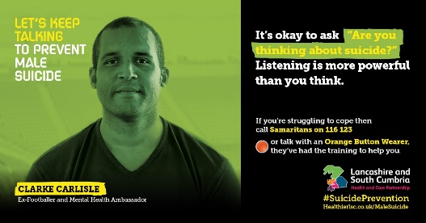  CC_digital_1.jpg (1200×628) (healthierlsc.co.uk)

Post World Suicide Prevention Day 10/9/21 posts

Please use the posts in the weeks following World Suicide Prevention Day. We suggest scheduling 1-2 posts a week. Please tag us where you can – @HealthierLSC

Copy | Image thumbnail/asset
Clarke Carlisle posts
Facebook and Insta  Ex-Premier League footballer Clarke Carlisle is backing our latest suicide prevention campaign.  Asking someone about suicide won’t put the idea into someone’s mind.  Let’s keep talking – ask your mate if you think they’re struggling 💙  Find out more 👉🏼 https://www.healthierlsc.co.uk/MaleSuicide  Twitter  Ex-Premier League footballer Clarke Carlisle is urging people to ‘keep talking’ in a bid to stop men from taking their own lives.  Asking someone about suicide won’t put the idea into someone’s mind.  Let’s keep talking 💙 Find out more 👉🏼 https://www.healthierlsc.co.uk/MaleSuicide | CC_digital_1.jpg (1200×628) (healthierlsc.co.uk)
Facebook, Insta and Twitter  Suicide is the biggest killer of men under 49… we can change that.  We’ve teamed up with ex-Blackpool, Burnley and Preston footballer Clarke Carlisle to encourage people to reach out if they’re struggling 💙  #StartTheConversation ➡️ https://www.healthierlsc.co.uk/MaleSuicide | CC_digital_2.jpg (1200×628) (healthierlsc.co.uk)
Facebook, Insta and Twitter  We’ve teamed up with ex-footballer Clarke Carlisle to talk about suicide and men’s mental health 👨🏾  Suicide is the biggest killer of men under 49 – we want to change this, we want to get men talking 🗣️  More info ➡️ https://www.healthierlsc.co.uk/MaleSuicide https://youtu.be/-uDAuaX3jso | When copying and pasting please ensure it is the YouTube video which displays in the post.
Facebook, Insta and Twitter  🗣️ Ever had a conversation about suicide? It’s not as scary as you might think, and it might just save a life.  Ex-Premier League footballer Clarke Carlisle is working with us to encourage more people to talk about suicide.  Find out more ➡️ https://www.healthierlsc.co.uk/MaleSuicide | 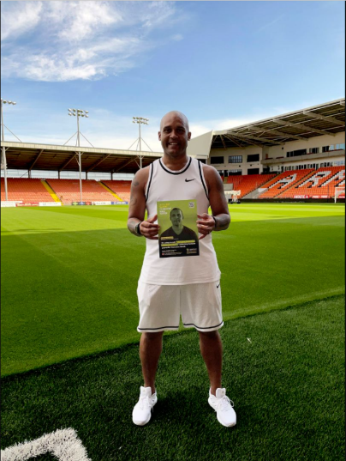  Clarke_Carlisle_1.jpg (810×1080) (healthierlsc.co.uk)
Facebook and Insta  Men are three times more likely to take their life by suicide than women.  And suicide rates across Lancs and South Cumbria are the third highest in England.  We’ve teamed up with ex-footballer Clarke Carlisle to encourage more men to open up about their mental health and talk about feelings of suicide 💙  Find out more ➡️ https://www.healthierlsc.co.uk/MaleSuicide  https://youtu.be/-uDAuaX3jso  Twitter  We’ve teamed up with ex-footballer Clarke Carlisle to encourage more men to open up about their mental health and talk about feelings of suicide 💙  Find out more ➡️ https://www.healthierlsc.co.uk/MaleSuicide  https://youtu.be/-uDAuaX3jso | When copying and pasting please ensure it is the YouTube video which displays in the post.
Orange Button posts
Facebook and Insta  🟠 People who are having thoughts of suicide can ‘push the button’ when they see someone wearing a distinctive orange badge and ask them for information and support.  The orange button is worn by people in Lancashire and South Cumbria who have undergone extensive suicide prevention training, and while they are not able to counsel people, they can provide comprehensive signposting to relevant services.  Find out more here 👉 https://www.healthierlsc.co.uk/OrangeButtonScheme  #OrangeButton #StartTheConversation @HealthierLSC  Twitter  🟠 People who are having thoughts of suicide can ‘push the button’ when they see someone wearing a distinctive orange badge and ask them for information and support.  Find out more here 👉 https://www.healthierlsc.co.uk/OrangeButtonScheme  #OrangeButton #StartTheConversation @HealthierLSC | 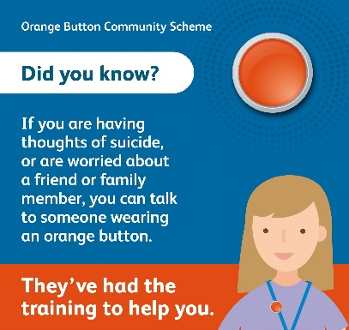  OB_1.jpg (1140×1080) (healthierlsc.co.uk)  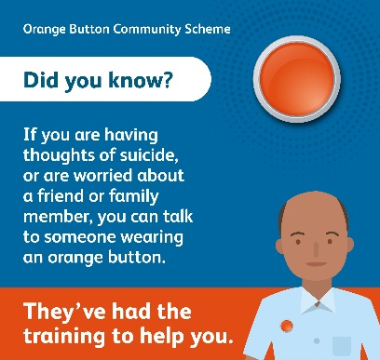  OB_2.jpg (1138×1080) (healthierlsc.co.uk)
Facebook, Insta and Twitter

🟠 Have you heard of the ‘orange button’ scheme?

It’s been set up to help people who are having thoughts of suicide, or who are worried about a friend or family member.

Find out more here 👉 https://www.healthierlsc.co.uk/OrangeButtonScheme
#OrangeButton #StartTheConversation @HealthierLSC

Facebook, Insta and Twitter

🟠 Are you worried a friend or family member could be having suicidal thoughts?

Let them know about the ‘orange button scheme’. There are people out there who can give them information and support at times when they’re struggling.

Find out more 👉 https://www.healthierlsc.co.uk/OrangeButtonScheme

Facebook, Insta and Twitter

🟠 If you’re having thoughts of suicide ‘push the orange button’.

If you see someone wearing a distinctive orange badge, they’ve been specially trained to offer you information and support.

Find out more here 👉 https://www.healthierlsc.co.uk/OrangeButtonScheme
#OrangeButton #StartTheConversation

Facebook, Insta and Twitter

🟠 Did you know, if you see someone wearing a distinctive ‘orange button’ they can help people who are having suicidal thoughts.

They can’t offer counselling, but they will be able to direct people to where they can get help.

Find out more here 👉 https://www.healthierlsc.co.uk/OrangeButtonScheme

Generic posts
Facebook and Twitter  It’s OK to ask someone you’re worried about, ‘are you thinking about suicide?’  Asking someone about suicide won’t put the idea into someone’s mind.  Let’s keep talking – ask your mate if you think they’re struggling 💙  #StartTheConversation ➡️ www.healthierlsc.co.uk/malesuicide | 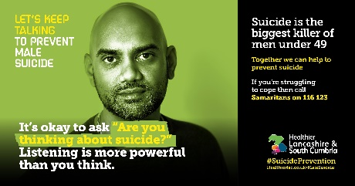  Male_suicide_social_phase_5_-_1.jpg (1920×1004) (healthierlsc.co.uk)
Facebook  Suicide – not the easiest subject to talk about, but we need to start.  Suicide rates across Lancs and South Cumbria are the third highest in England and men are three times more likely to take their life by suicide than women.  We want to change this. If you’re worried about your mate it’s OK to ask, ‘are you thinking about suicide?’ 💙  #StartTheConversation➡️ www.healthierlsc.co.uk/malesuicide  Twitter  Suicide – not the easiest subject to talk about, but we need to start. Men are three times more likely to take their life by suicide than women.  We want to change that 💙  #StartTheConversation ➡️ www.healthierlsc.co.uk/malesuicide | 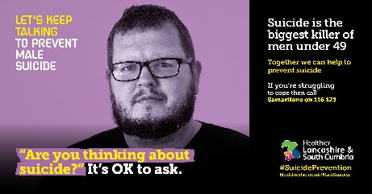  Male_suicide_social_phase_5_-_2.jpg (1920×1004) (healthierlsc.co.uk)
Facebook and Twitter  ❓ ‘Are you thinking about suicide?’  It’s a bold question, but it’s OK to ask if you’re worried about someone.  #StartTheConversation ➡️ www.healthierlsc.co.uk/malesuicide | 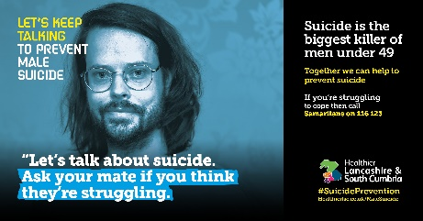  Male_suicide_social_phase_5_-_3.jpg (1920×1004) (healthierlsc.co.uk)
Facebook and Twitter  Let’s talk about suicide.  We get it’s not the easiest of subjects, but it’s so important if we want to save lives.  Men are three times more likely to take their life by suicide than women. So, we need to get men talking 🗣️  #StartTheConversation ➡️ www.healthierlsc.co.uk/malesuicide | 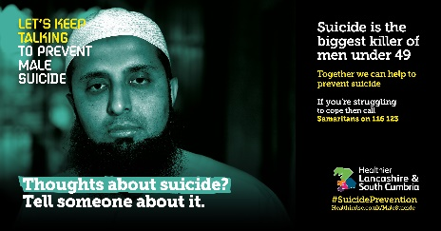  Male_suicide_social_phase_5_-_4.jpg (1920×1004) (healthierlsc.co.uk)
Facebook  Suicide is the biggest killer of men under 49 and men are three times more likely to take their life by suicide than women.  So, let’s get men talking! 👨🏾👨🏼👨🏻🗣️  If you’re worried about your mate it’s OK to ask, ‘are you thinking about suicide?’  #StartTheConversation 👉🏼 www.healthierlsc.co.uk/malesuicide  Twitter  Suicide is the biggest killer of men under 49 and men are three times more likely to take their life by suicide than women.  So, let’s get men talking! 👨🏾👨🏼👨🏻🗣️ If you’re worried about your mate it’s OK to ask, ‘are you thinking about suicide?’👉🏼 www.healthierlsc.co.uk/malesuicide | https://youtu.be/XKwcFuIYACg  or  https://youtu.be/MiD8zh9ne9E

World Suicide Prevention Day

Use the official hashtags, #WorldSuicidePreventionDay, #WSPD, #bethelight or #WSPD2021 to join the conversation and help spread awareness of suicide prevention on social media.

The images below are for illustrative purposes only, the high-resolution versions can be downloaded at Resources - IASP WSPD Resources, Brief, Banners, Light a Candle, along with a number of other resources.

Social media images

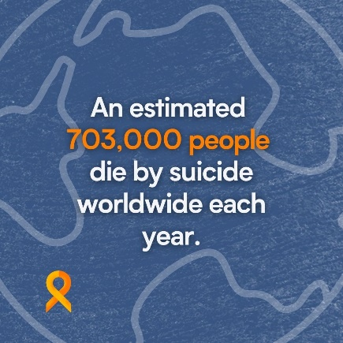 | 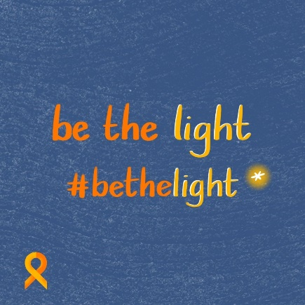 | 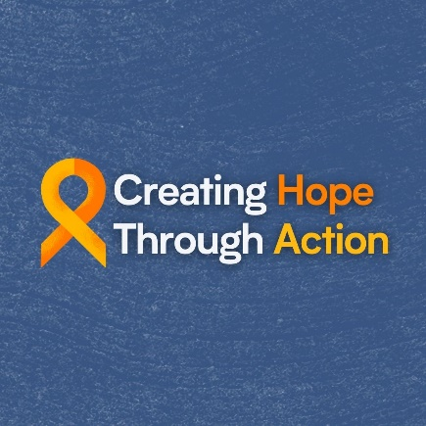
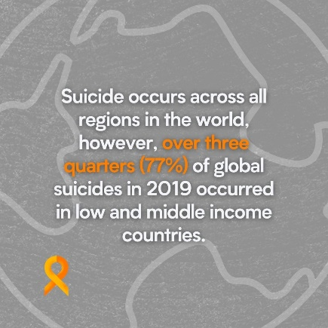 | 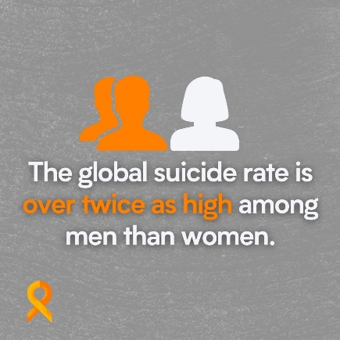 | 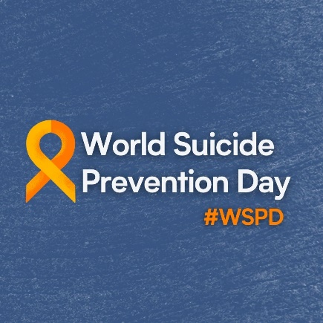
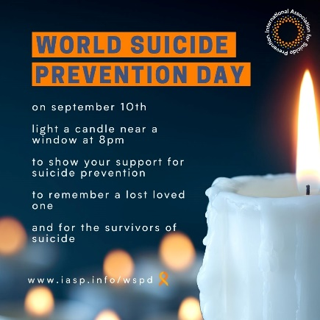

Banners

